**CONCLUSION (POWER BI ANALYSIS)**

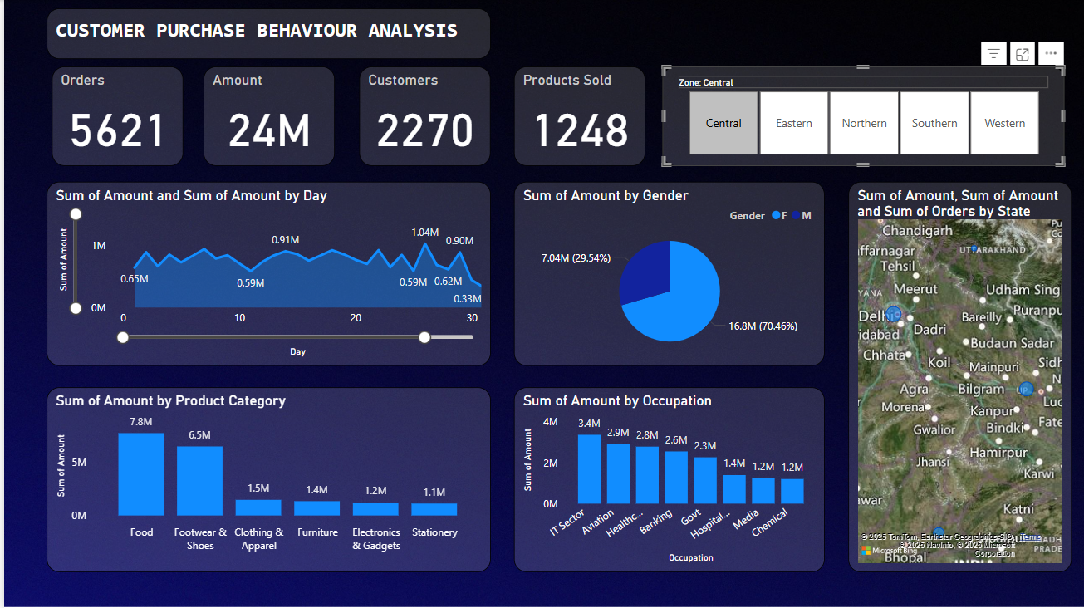**Dashboard 1: Central Region (Orders: 5,621)**

**Overview Metrics**

* **Orders**: 5,621
* **Amount**: 24M
* **Customers**: 2,270
* **Products Sold**: 1,248

**Sales Trends**

* **Sum of Amount by Day**:
  + Daily sales fluctuate between 0.59M and 1.04M over a 30-day period.
  + The highest peak is 1.04M around day 15, with lows at 0.59M and 0.62M towards the end.
  + **Conclusion**: Sales in the Central region show moderate daily fluctuations, with a noticeable peak mid-month, suggesting a potential promotional or seasonal effect.

**Gender Distribution**

* **Sum of Amount by Gender**:
  + Females contribute 7.04M (29.54%), and males contribute 16.80M (70.46%).
  + **Conclusion**: Males in the Central region contribute significantly more to sales amounts (70.46%) compared to females (29.54%), indicating a gender disparity in purchasing power.

**Regional Distribution**

* **Sum of Amount and Orders by State**:
  + High sales are concentrated in states like Delhi, Chandigarh, and Uttar Pradesh.
  + **Conclusion**: Delhi, Chandigarh, and Uttar Pradesh are the key sales drivers in the Central region, reflecting higher economic activity in these areas.

**Product Categories**

* **Sum of Amount by Product Category**:
  + Food leads at 7.8M, followed by Footwear & Shoes (6.5M), Clothing & Apparel (1.5M), Electronics & Gadgets (1.4M), Furniture (1.2M), and Stationery (1.1M).
  + **Conclusion**: Food dominates sales in the Central region, followed by Footwear & Shoes, while categories like Stationery and Furniture have lower contributions, indicating a preference for essential and lifestyle products.

**Occupations**

* **Sum of Amount by Occupation**:
  + IT Sector leads at 0.78M, followed by Aviation (0.57M), Healthcare (0.57M), Banking (0.53M), Government (0.36M), and Hospital (0.34M).
  + **Conclusion**: Professionals in IT, Aviation, and Healthcare are the top buyers in the Central region, suggesting these sectors are key target markets.

**Dashboard 2: Eastern Region (Orders: 1,439)**

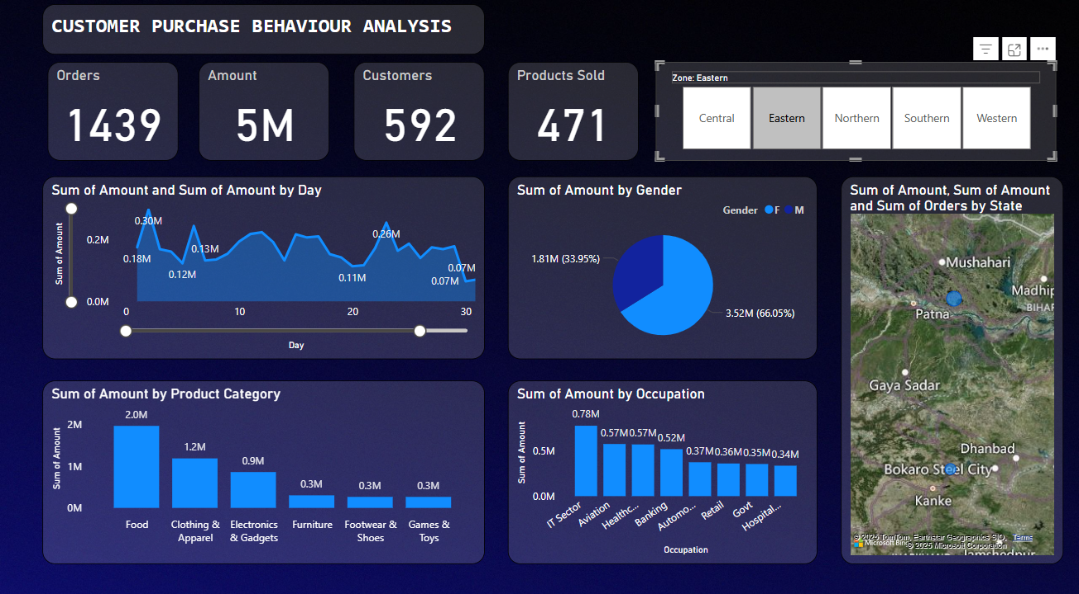

**Overview Metrics**

* **Orders**: 1,439
* **Amount**: 5M
* **Customers**: 592
* **Products Sold**: 471

**Sales Trends**

* **Sum of Amount by Day**:
  + Daily sales fluctuate between 0.07M and 0.26M over a 30-day period.
  + The highest peak is 0.26M around day 20, with a low of 0.07M towards the end.
  + **Conclusion**: Sales in the Eastern region are relatively low and show a sharp decline towards the end of the period, indicating potential economic or logistical challenges.

**Gender Distribution**

* **Sum of Amount by Gender**:
  + Females contribute 1.81M (33.95%), and males contribute 3.52M (66.05%).
  + **Conclusion**: Males in the Eastern region contribute more to sales amounts (66.05%) compared to females (33.95%), consistent with the gender disparity seen in other regions.

**Regional Distribution**

* **Sum of Amount and Orders by State**:
  + Sales are concentrated in states like Patna, Gaya, and Bihar.
  + **Conclusion**: Patna, Gaya, and Bihar are the primary sales contributors in the Eastern region, though overall sales are lower compared to other zones.

**Product Categories**

* **Sum of Amount by Product Category**:
  + Food leads at 2.0M, followed by Clothing & Apparel (1.2M), Electronics & Gadgets (0.9M), Furniture (0.3M), Footwear & Shoes (0.3M), and Games & Toys (0.3M).
  + **Conclusion**: Food is the top category in the Eastern region, followed by Clothing & Apparel and Electronics & Gadgets, with smaller categories like Furniture and Games & Toys showing minimal impact.

**Occupations**

* **Sum of Amount by Occupation**:
  + IT Sector leads at 1.00M, followed by Healthcare (0.97M), Aviation (0.77M), Banking (0.56M), Government (0.35M), and Media (0.34M).
  + **Conclusion**: IT Sector, Healthcare, and Aviation professionals are the top buyers in the Eastern region, indicating these occupations as key customer segments.

**Dashboard 3: Northern Region (Orders: 2,064)**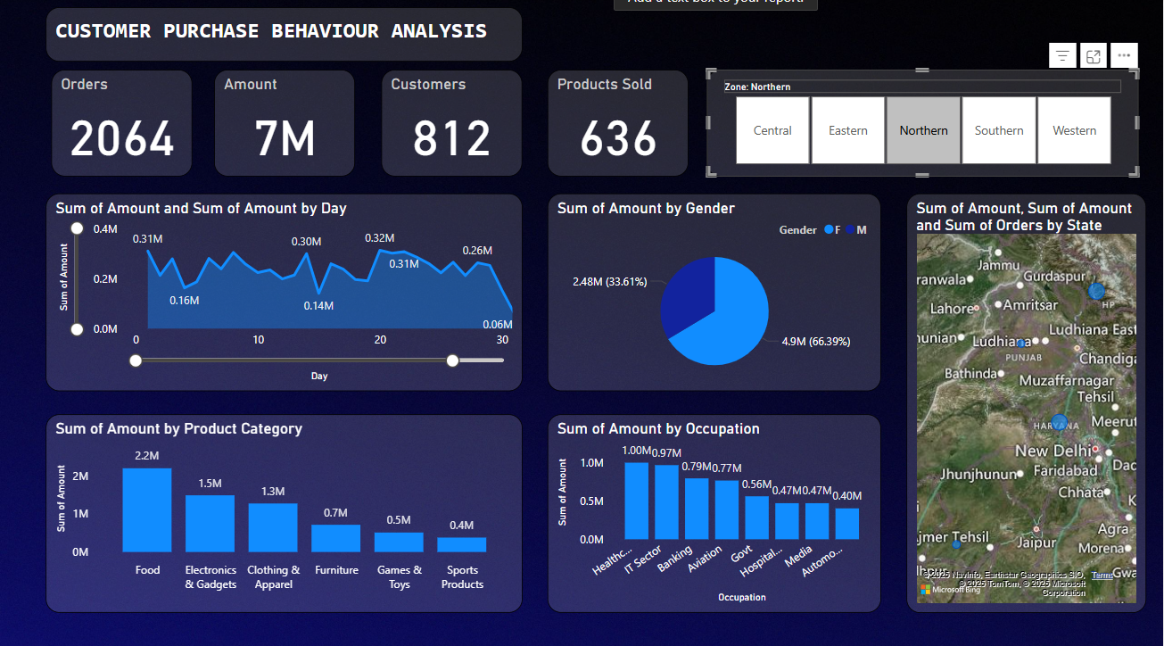

**Overview Metrics**

* **Orders**: 2,064
* **Amount**: 7M
* **Customers**: 812
* **Products Sold**: 636

**Sales Trends**

* **Sum of Amount by Day**:
  + Daily sales fluctuate between 0.14M and 0.46M over a 30-day period.
  + The highest peak is 0.46M around day 15, with a low of 0.14M towards the end.
  + **Conclusion**: Sales in the Northern region show moderate fluctuations, with a peak mid-month and a decline towards the end, suggesting a possible seasonal trend.

**Gender Distribution**

* **Sum of Amount by Gender**:
  + Females contribute 2.48M (33.61%), and males contribute 4.90M (66.39%).
  + **Conclusion**: Males in the Northern region contribute more to sales amounts (66.39%) compared to females (33.61%), aligning with the gender disparity trend.

**Regional Distribution**

* **Sum of Amount and Orders by State**:
  + Sales are concentrated in states like Ludhiana, Amritsar, and Chandigarh.
  + **Conclusion**: Ludhiana, Amritsar, and Chandigarh are the key sales drivers in the Northern region, though overall sales are lower than in Central or Southern zones.

**Product Categories**

* **Sum of Amount by Product Category**:
  + Food leads at 2.2M, followed by Electronics & Gadgets (1.5M), Clothing & Apparel (1.3M), Furniture (0.7M), Footwear & Shoes (0.5M), and Games & Toys (0.4M).
  + **Conclusion**: Food dominates sales in the Northern region, followed by Electronics & Gadgets and Clothing & Apparel, with smaller categories like Games & Toys showing minimal contribution.

**Occupations**

* **Sum of Amount by Occupation**:
  + IT Sector leads at 2.6M, followed by Healthcare (2.5M), Aviation (2.0M), Banking (1.6M), Media (1.2M), and Government (1.0M).
  + **Conclusion**: IT Sector, Healthcare, and Aviation professionals are the top buyers in the Northern region, consistent with other zones.

**Dashboard 4: Southern Region (Orders: 4,637)**

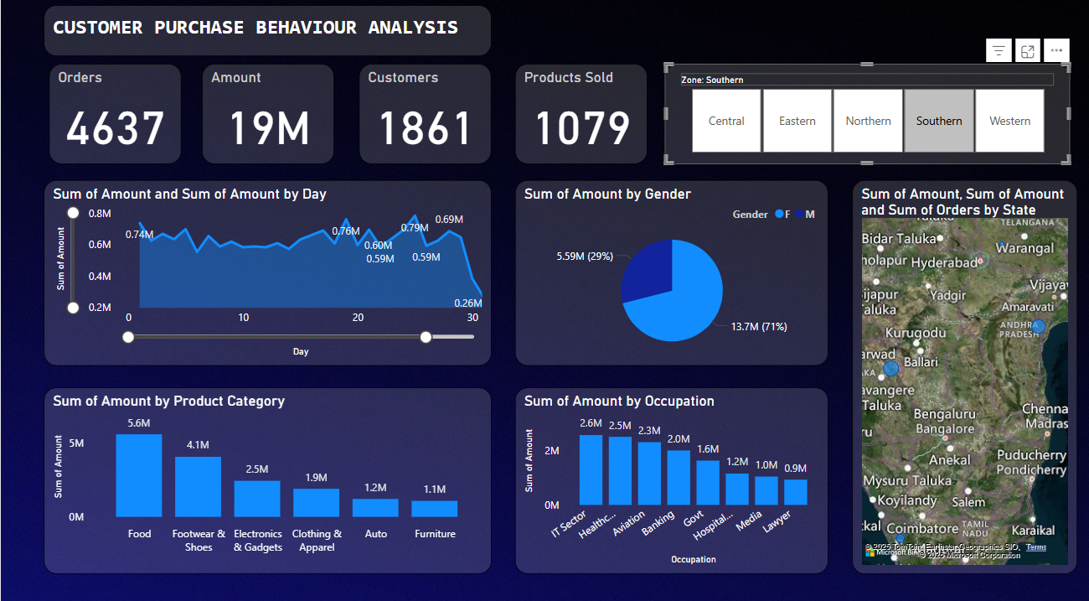

**Overview Metrics**

* **Orders**: 4,637
* **Amount**: 19M
* **Customers**: 1,861
* **Products Sold**: 1,079

**Sales Trends**

* **Sum of Amount by Day**:
  + Daily sales fluctuate between 0.59M and 0.79M over a 30-day period.
  + The highest peak is 0.79M around day 20, with a low of 0.59M towards the end.
  + **Conclusion**: Sales in the Southern region show relatively stable fluctuations, with a peak towards the end of the period, indicating sustained demand.

**Gender Distribution**

* **Sum of Amount by Gender**:
  + Females contribute 5.99M (29%), and males contribute 14.71M (71%).
  + **Conclusion**: Males in the Southern region contribute significantly more to sales amounts (71%) compared to females (29%), consistent with the gender disparity trend.

**Regional Distribution**

* **Sum of Amount and Orders by State**:
  + Sales are concentrated in states like Hyderabad, Bengaluru, and Chennai.
  + **Conclusion**: Hyderabad, Bengaluru, and Chennai are the primary sales contributors in the Southern region, reflecting strong economic activity in these cities.

**Product Categories**

* **Sum of Amount by Product Category**:
  + Food leads at 5.6M, followed by Footwear & Shoes (4.1M), Electronics & Gadgets (2.5M), Clothing & Apparel (1.9M), Auto (1.2M), and Furniture (1.1M).
  + **Conclusion**: Food dominates sales in the Southern region, followed by Footwear & Shoes and Electronics & Gadgets, with categories like Auto and Furniture showing moderate contributions.

**Occupations**

* **Sum of Amount by Occupation**:
  + IT Sector leads at 1.5M, followed by Healthcare (1.4M), Aviation (1.3M), Banking (1.0M), Media (0.7M), and Government (0.7M).
  + **Conclusion**: IT Sector, Healthcare, and Aviation professionals are the top buyers in the Southern region, aligning with trends in other zones.

**Dashboard 5: Western Region (Orders: 2,617)**

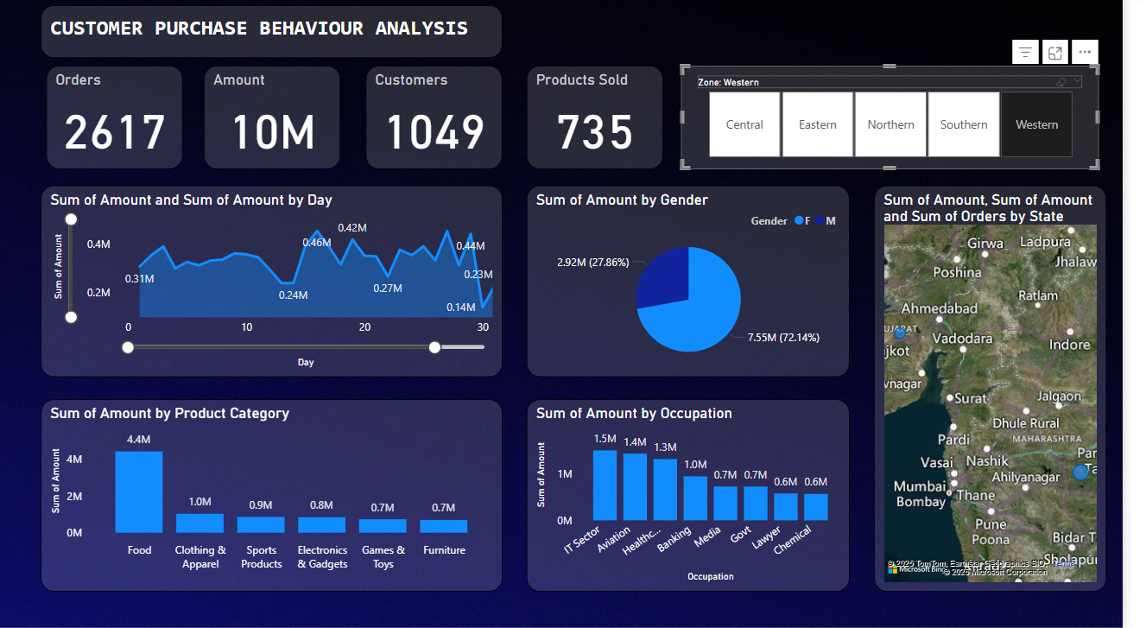

**Overview Metrics**

* **Orders**: 2,617
* **Amount**: 10M
* **Customers**: 1,049
* **Products Sold**: 735

**Sales Trends**

* **Sum of Amount by Day**:
  + Daily sales fluctuate between 0.14M and 0.46M over a 30-day period.
  + The highest peak is 0.46M around day 15, with a low of 0.14M towards the end.
  + **Conclusion**: Sales in the Western region show moderate fluctuations, with a peak mid-month and a decline towards the end, similar to the Northern region.

**Gender Distribution**

* **Sum of Amount by Gender**:
  + Females contribute 2.92M (27.86%), and males contribute 7.55M (72.14%).
  + **Conclusion**: Males in the Western region contribute significantly more to sales amounts (72.14%) compared to females (27.86%), following the gender disparity trend.

**Regional Distribution**

* **Sum of Amount and Orders by State**:
  + Sales are concentrated in states like Mumbai, Pune, and Nashik.
  + **Conclusion**: Mumbai, Pune, and Nashik are the key sales drivers in the Western region, reflecting strong economic activity in these areas.

**Product Categories**

* **Sum of Amount by Product Category**:
  + Food leads at 4.4M, followed by Clothing & Apparel (1.0M), Sports Products (0.9M), Electronics & Gadgets (0.8M), Games & Toys (0.7M), and Furniture (0.7M).
  + **Conclusion**: Food dominates sales in the Western region, followed by Clothing & Apparel and Sports Products, with smaller categories like Games & Toys and Furniture showing minimal impact.

**Occupations**

* **Sum of Amount by Occupation**:
  + IT Sector leads at 1.4M, followed by Healthcare (1.3M), Aviation (1.0M), Banking (0.7M), Government (0.7M), and Media (0.6M).
  + **Conclusion**: IT Sector, Healthcare, and Aviation professionals are the top buyers in the Western region, consistent with other zones.

**Dashboard 6: All Zones (Orders: 16K)**

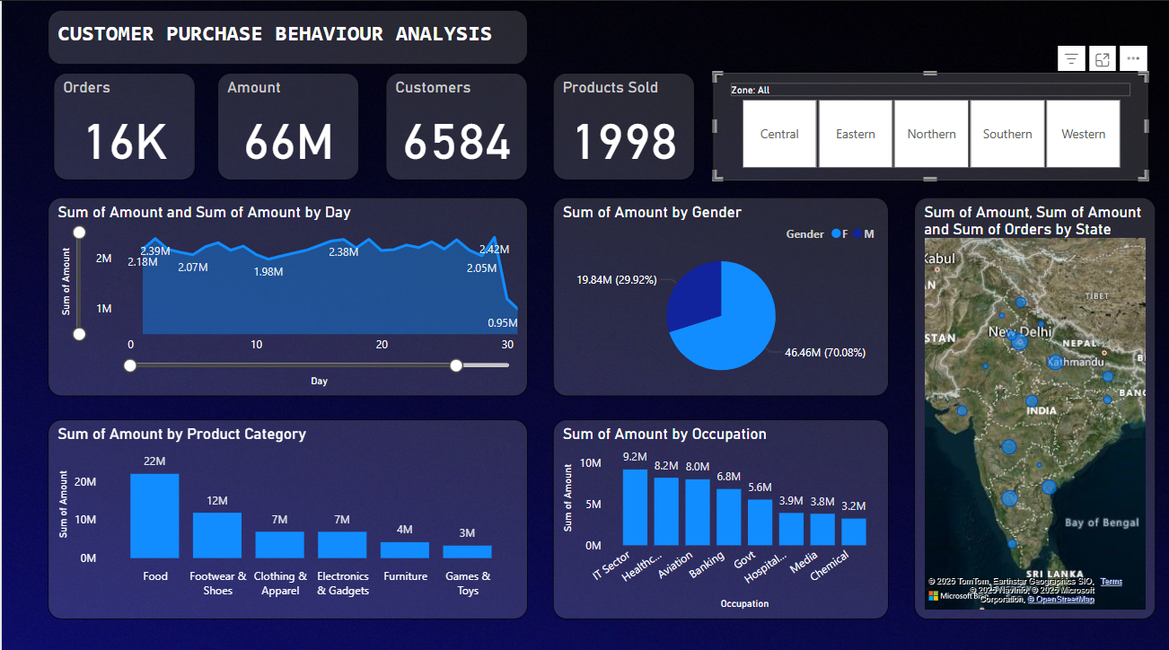

**Overview Metrics**

* **Orders**: 16,000
* **Amount**: 66M
* **Customers**: 6,584
* **Products Sold**: 1,998

**Sales Trends**

* **Sum of Amount by Day**:
  + Daily sales fluctuate between 0.95M and 2.42M over a 30-day period.
  + The highest peak is 2.42M around day 20, with a low of 0.95M towards the end.
  + **Conclusion**: Sales across all zones show significant fluctuations, with a peak mid-month and a decline towards the end, indicating a broader trend of seasonal or promotional impacts.

**Gender Distribution**

* **Sum of Amount by Gender**:
  + Females contribute 19.84M (29.92%), and males contribute 46.46M (70.08%).
  + **Conclusion**: Males across all zones contribute significantly more to sales amounts (70.08%) compared to females (29.92%), consistent with the gender disparity trend.

**Regional Distribution**

* **Sum of Amount and Orders by State**:
  + Sales are concentrated in cities like Delhi, Mumbai, and Bengaluru, with additional contributions from states like Uttar Pradesh, Maharashtra, and Karnataka.
  + **Conclusion**: Delhi, Mumbai, and Bengaluru are the top sales drivers across all zones, reflecting their status as economic hubs, with Uttar Pradesh, Maharashtra, and Karnataka also contributing significantly.

**Product Categories**

* **Sum of Amount by Product Category**:
  + Food leads at 22M, followed by Footwear & Shoes (12M), Clothing & Apparel (7M), Electronics & Gadgets (7M), Furniture (4M), and Games & Toys (3M).
  + **Conclusion**: Food dominates sales across all zones, followed by Footwear & Shoes, Clothing & Apparel, and Electronics & Gadgets, with categories like Furniture and Games & Toys showing lower contributions.

**Occupations**

* **Sum of Amount by Occupation**:
  + IT Sector leads at 9.2M, followed by Healthcare (8.2M), Aviation (8.0M), Banking (6.8M), Government (5.6M), and Media (3.9M).
  + **Conclusion**: IT Sector, Healthcare, and Aviation professionals are the top buyers across all zones, indicating these occupations as key customer segments.

**Sales Forecasting Dashboards**

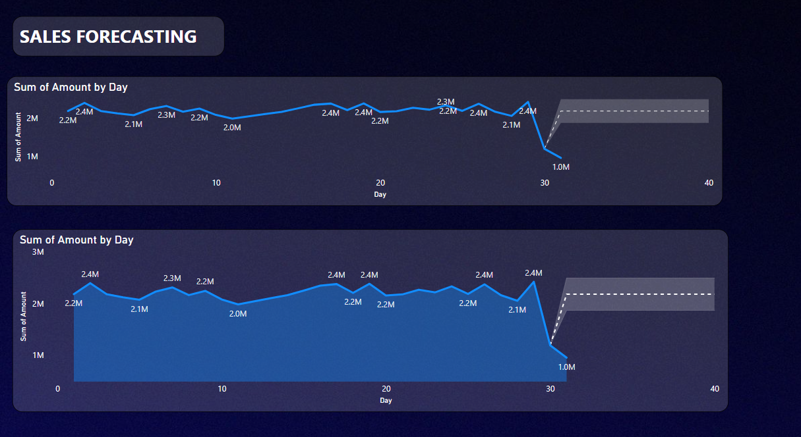

**Sales Trends and Forecast**

* **Sum of Amount by Day**:
  + Historical sales fluctuate between 2.0M and 2.4M over 30 days, with peaks around 2.4M and lows around 2.0M.
  + The forecast predicts a sharp decline starting around day 30, dropping to 1.0M by day 40 in both charts.
  + **Conclusion**: Sales are expected to decline significantly after day 30, dropping to 1.0M by day 40, suggesting potential challenges or a seasonal downturn that needs to be addressed.